# HINDUSTHAN COLLEGE OF ENGINEERING AND TECHNOLOGY

**(AUTONOMOUS)**

|  |  |
| --- | --- |
| Team ID | PNT2022TMID09987 |
| Project Name | Project – Smart Waste Management System for Metropolitan Cities |

# SPRINT 2:

In this sprint we have created IBM Watson internet of things platform cloud services and 2 devices, one for publishing sensor data another one for subscribing to alert system.

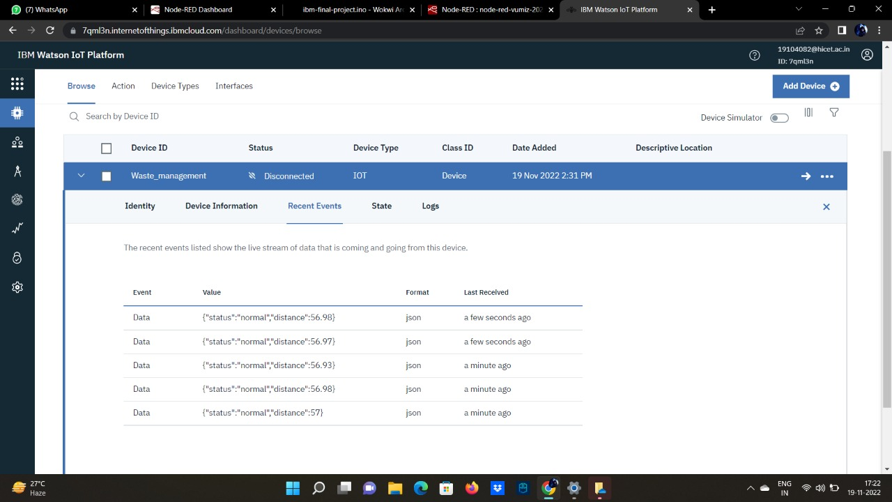

Here the random sensor data are successfully published in the json format from the python code that we have developed during the previous sprint.